Walk with Ease Iowa
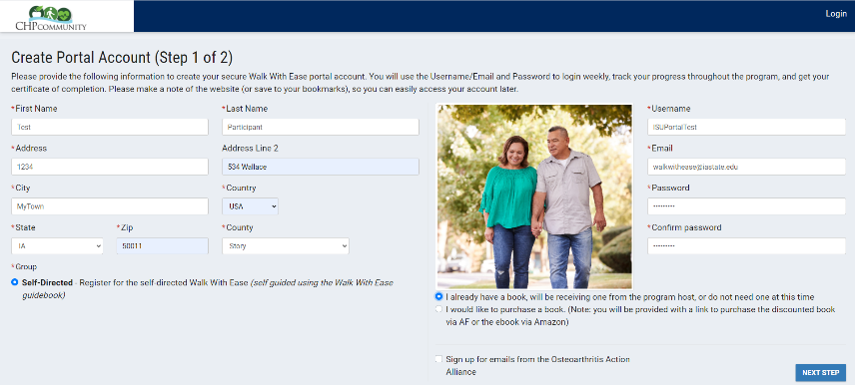
OAAA Portal Overview

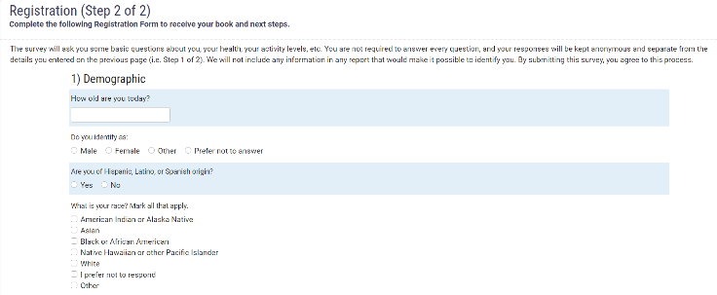

The OAAA Portal allows participants to individually create a portal account to register for the program, provide demographic and baseline data, and receive a link to purchase the participant guidebook. For a limited time participants enrolling in ongoing evaluation of program enhancements can provide shipping information to have guidebook costs covered by the ISU Physical Activity and Health Promotion Lab!

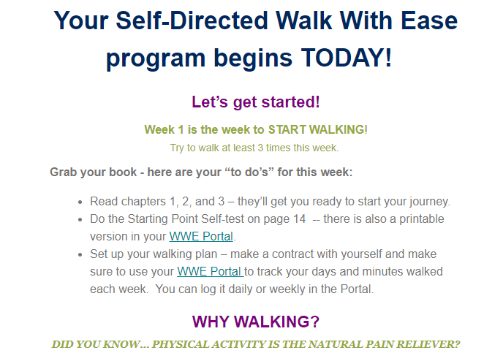

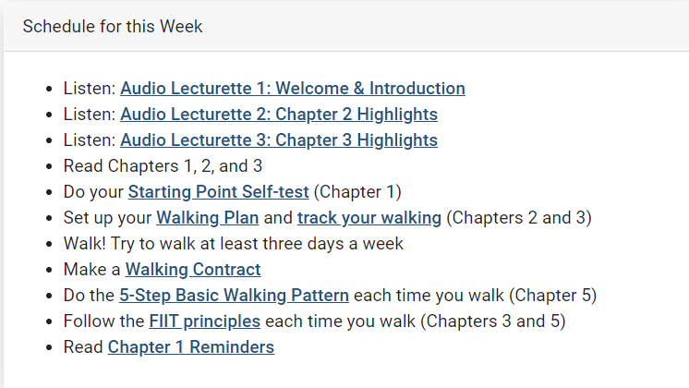
After enrolling, participants receive a weekly email series designed to help remind them of weekly readings and activities, provide information on key Guidebook topics, and encouraging them to visit the portal to track their weekly walking and set goals for the coming weeks

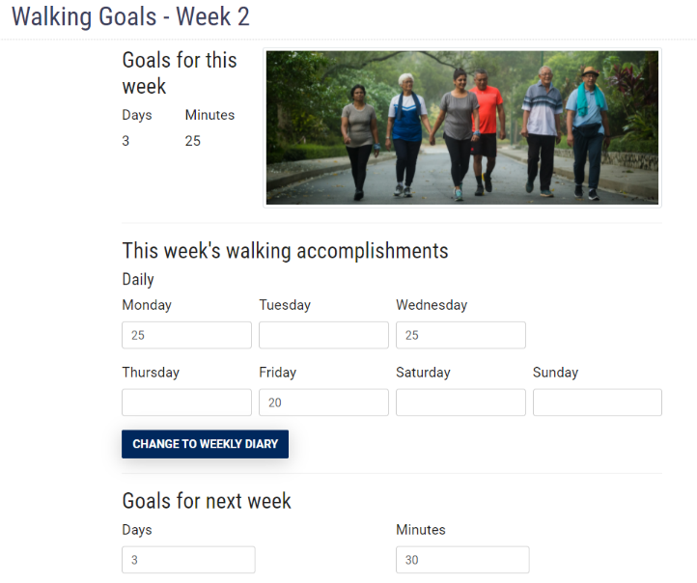

By visiting the portal regularly, WWE participants are able to set weekly goals and track their walking, as well as receive feedback on their progress towards the recommended 150 minutes of weekly moderate activity.
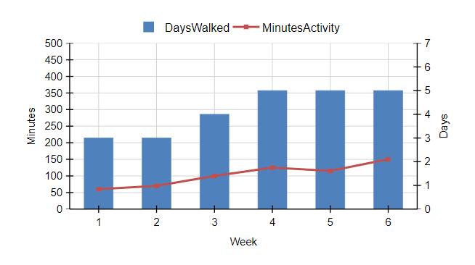

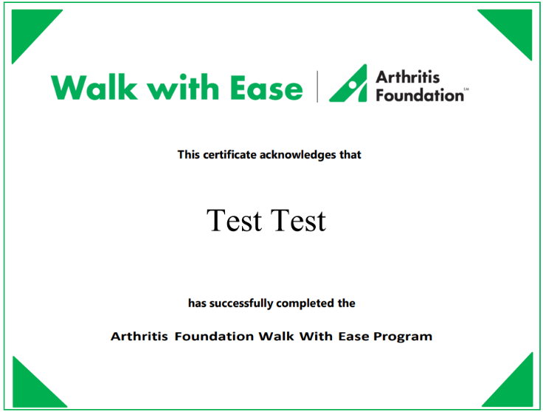
Upon completion of the program and the post-participation evaluation, the Portal will provide each participant with a certificate of completion, that can be used to document a commitment to a healthy lifestyle with a health care provider or other interested party.

